**Budget Planner**

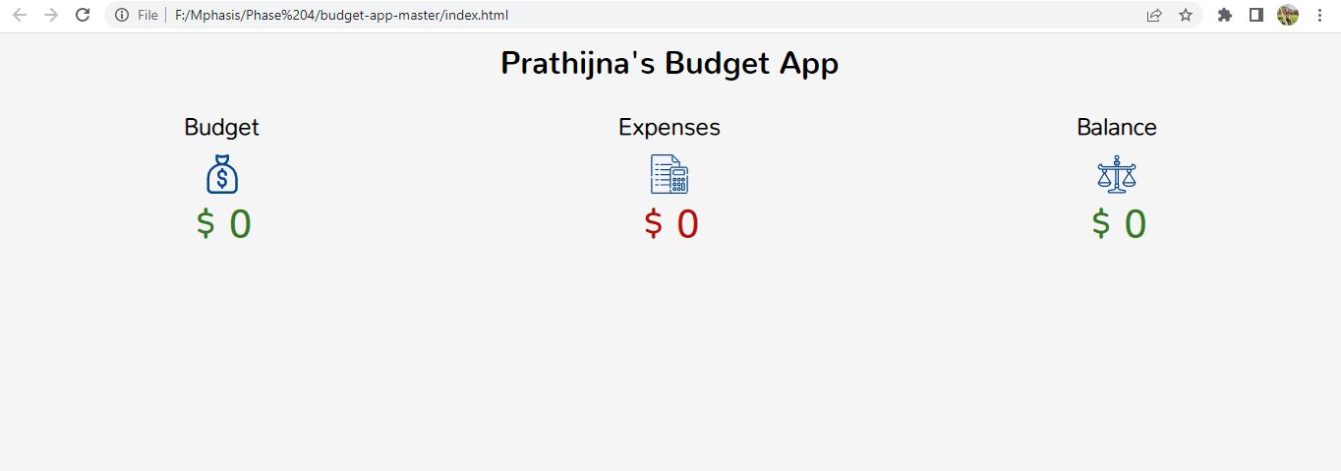

* Whatever we plan to do, we fix budget first
* Then we can divide the expense within that budget.
* Then we will get balance after the expense

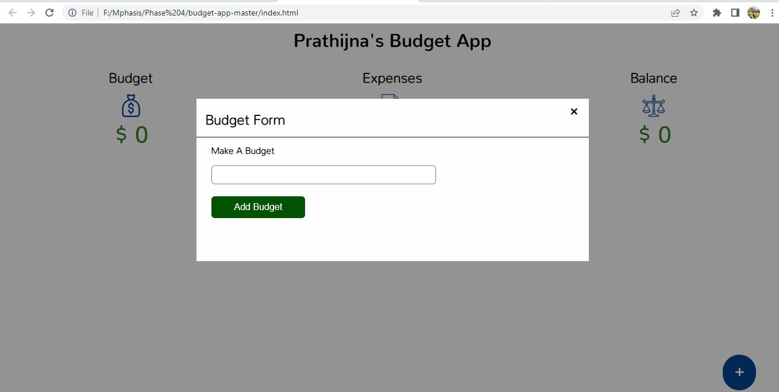

* Initially we need to fix the budget.
* So users are allowed to enter their budget

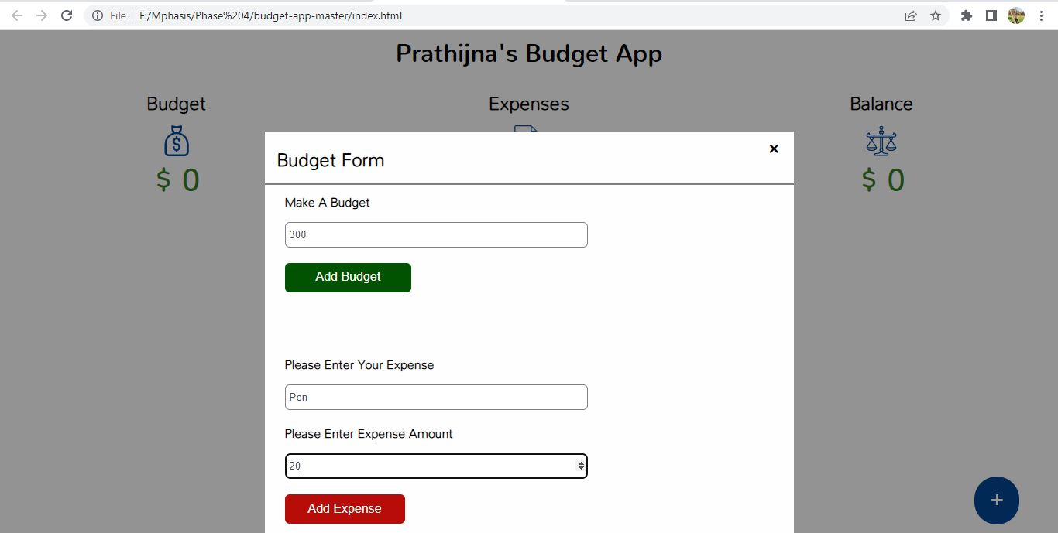

* When user clicks on + sign at right bottom
* They will get this pop up
* where they can set the budget and mention the expense name and cost for that expense.
* Then they have to click on add expense.

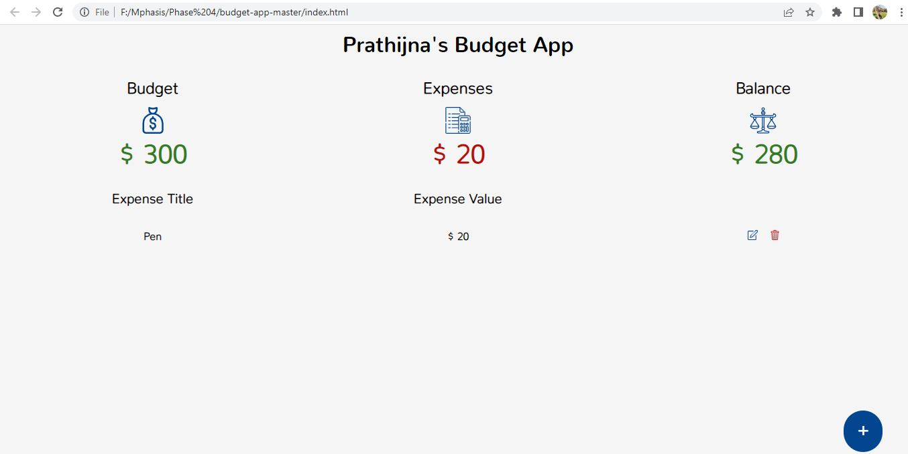

* Here the budget is fixed, and first expense is added
* Budget and expense is calculated and balance is reflected

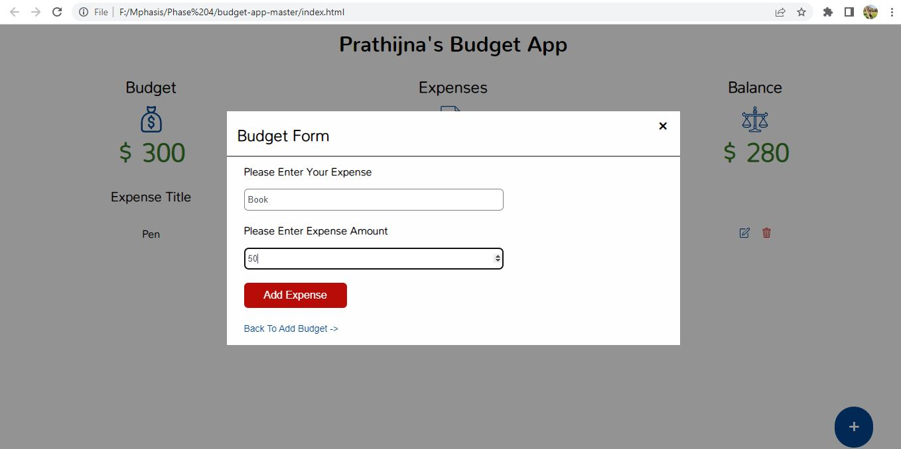

* Another expense is added

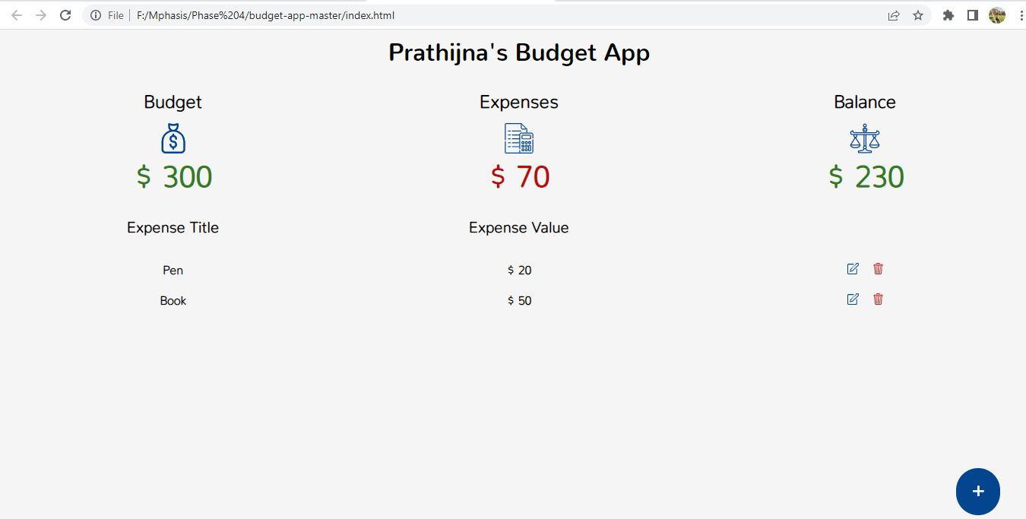

* Second expense is added and expense total and balance total is calculated and changed